Graphical User Interface (GUI) Plan

1. Using Pycharm, create a webpage layout for the GUI. The design must first feature a button displaying the ‘Brainvire Ltd.’ logo, with the title ‘IT Support’ attached to it. An example design is displayed below:

**IT Support**

1. This GUI button above must then allow the user to click on it, triggering it to display three option buttons. The first button will be ‘Support’, the second button will be ‘Services’ and the third button will be ‘Public’. This is shown is an example design below:

Support

Services

Public

1. 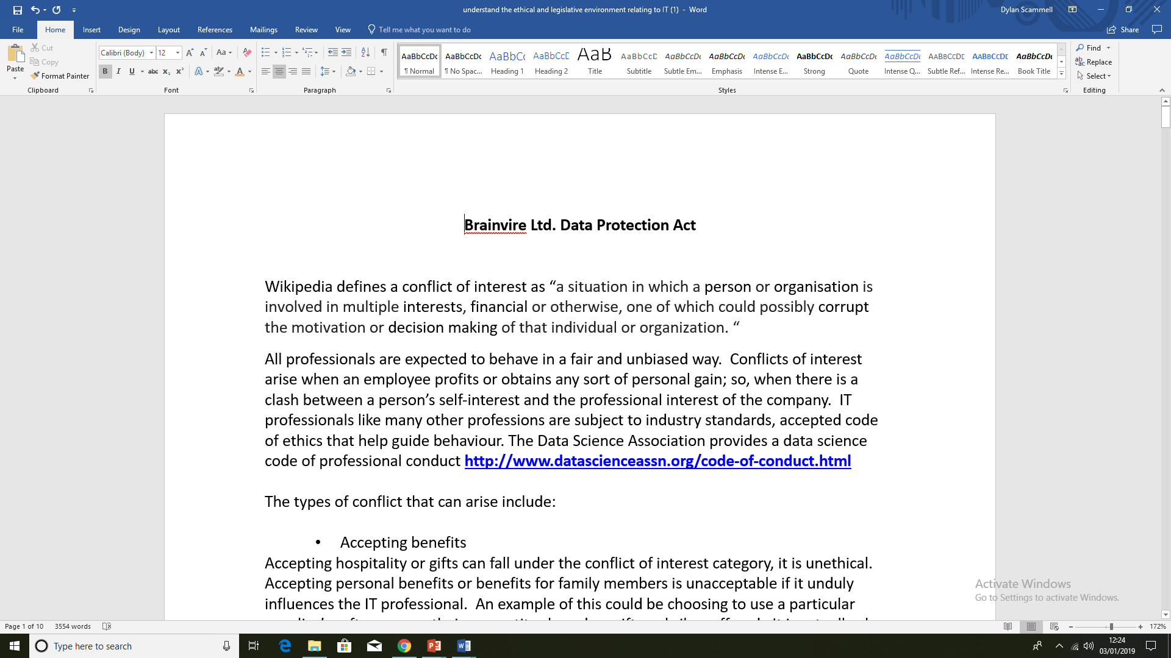When either of these buttons are clicked on by the user, they will be redirected to different documents. For example, if the user was to click on the ‘Public’ option button, they would open the company’s data protection act document, as shown below: